Individual Research Report
Rubric Feedback – Row 3
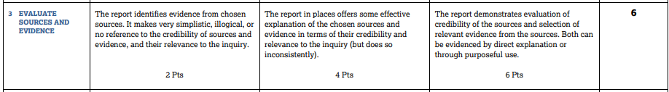
In this part of the rubric the key questions are this: Is the evidence well-selected and well-used? Is it consistently relevant and credible? Readers are told to look at any time evidence is used and at your works cited.
To score a 6 here you will want to
- Use the academic discourse stems we’ve given you to describe why the author of your source is credible
- Descriptions should be there to purposefully make the reader care about this person’s argument.
- Don’t treat all sources as equal. Try to add 2 to 3 times in your IRR when you give commentary about the credibility of your source making you either value or devalue their argument more or less.
- Focus on the author and not just the source of the publication as this is in the Works Cited.
- If you are using “in the article” or “according to this source” you are doing this wrong.
- If you are doing too much of this in a clunky way, it will kill your writing so only do what is necessary. Don’t include the entire author’s biography.
Do this: Purposeful credibility
Editor of the Chronicle of Higher Education, Joshua Hatch, supports this evidence from an educational perspective giving evidence from male professors earning $113,766 compared to the $95,622 of their female counterparts (5).
Gary Orfield, a professor at UCLA and co-director of the university’s Civil Rights Project, also comments upon the impact of the Miliken vs. Bradley case highlighting that it should have “desegregated students from the largely minority city schools with suburban students in metropolitan Detroit”(2).
Findings in the above study are consistent with a diplomat of the American Board of Psychiatry and Neurology doctor, Leo Sher’s, and a magistrate judge, Timothy Rice’s, findings, the two claim “the development of the human brain and emotion regulation processes are intimately affected by testosterone” (2). While Timothy Rice is not entirely credible due to his occupation being unrelated to the study, senior editor of “New York’s the Cut,” Melissa Dahl, notes that this view is supported by Ad Vingerhoets a professor of Clinical Psychology at Tilburg University which argues low testosterone levels cause men to become more emotional, inhibiting increased crying (2).
Stefane Kabene gathered data from a global research study conducted by the United Nations SPSS. The data revealed that, “countries with fewer women in positions of political leadership, corruption is perceived as being high”...”countries where people feel happier are those where gender equality is the strongest,” (Kabene 6). Sociology researchers like Kabene are finding that a decreased number of women in government positions of leadership is evidently linked to increased corruptness and discrimination.
Don’t do this
Focus on the article and not the author - An article from the Journal of College Counseling includes that posttraumatic stress disorder (frequently referred to as PTSD) and depression, as well as cognitive, affective, and behavioral disequilibrium are all potential psychological impacts of sexual assault (Lee, Caruso, et al.)
Give their entire life story –assess credibility, but don’t over assess. You are not writing their resume and you are wasting valuable words. According to Tracy Weitz, Director of the Advancing New Standards of Reproductive Health at the University of California, San Francisco with a doctorate in public administration, as well as an Associate Professor in the field of gynecology and reproductive health, “since 1995, over 600 state laws have passed to restrict some aspect of abortion, including waiting periods, funding restrictions, and restrictive facilities requirements” (2).
Skip it altogether - Relativity's theoretical foundations can be traced to earlier work by Faraday and Maxwell (Einstein 782).

