Individual Research Report
Rubric Feedback – Row 2
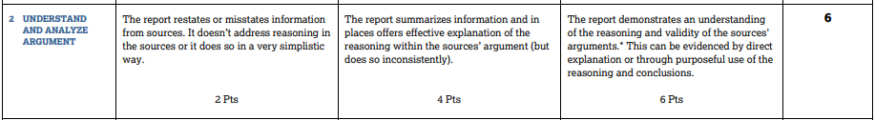
In this part of the rubric the key question is this: Does the report demonstrate an understanding of the REASONING and VALIDITY of ARGUMENTS from the sources they have used? Graders are told to look at your commentary directly following a citation or at the end of your paragraph.
To score a 6 here you will want to
- Present arguments from your sources
- Provide commentary about the reasoning and the validity of those arguments
- If you are just citing facts, you are headed in the wrong direction. You also may need to paraphrase instead of just quoting as some arguments from authors are developed over long sections of text.
On the left, is a model paragraph from a WHS AP Sem Scholar that does a great job discussing arguments. On the right, is a paragraph from the College Board that doesn’t . The paragraph on the right could be very effective in an informative essay but doesn’t help in an IRR because it isn’t about the authors’ arguments.
Do this  In order to properly decrease sexual assault rates among U.S colleges, states need to be on the same page. Ashley Hartmann of the Washington University Journal of Law & Policy compares the Clery Act to college rules by stating that “definitions of sexual assault may be very different from those used in university student conduct code definitions” (Hartmann 86). Dianne Carmody, Jessica Ekhomu, and Brian K. Payne of the College Student Journal add on to Hartmann’s statement by explaining how “campuses are left to interpret laws such as the Clery Act on their own” which results in a potential harm to victims (Carmody, Ekhomu, et al. 43). Eleanor Christie Gourley of the Washington University Journal of Law & Policy describes California’s Affirmative Consent Law (ACL) and how educational institutions in California that receive state and federal funds “must change their internal sexual assault policies to an affirmative consent standard” (Gourley 43). Of the Golden Gate University Law Review, Elizabeth Youngberg points out how the California Law is a only a part of what should be a series of expectations set for colleges as they adjudicate claims of any sexual assault and misconduct on their campuses. She also explains how if colleges across the nation developed laws such as the ACL, each state would have strict consent rules that would apply to every college student (Youngberg 64). Colleges across the nation interpret the definition of sexual assault differently, and by already not knowing the consent situation during the assault, legal action is made more difficult by colleges not having set and strict procedures to follow. | Don’t just do this. This is just an informative essay on the effects of climate change.  Another major sociocultural effect due to global climate change is the change in agriculture and jobs. There are many effects on agriculture due to climate change. Agriculture is a major part of the economies of many Arctic societies and is important in the daily lives’ of their inhabitants. Climate change makes it “...more difficult to grow crops, raise animals, and catch fish…” as the same as people did in the past (“Climate Impacts on Agriculture and Food Supply”). Ecosystems of the animals that are relied on are going to change due to warmer water temperatures. In addition, there are many effects on jobs because of climate change. Due to new industries and companies, many Arctic residents will have more job opportunities. Another effect on jobs is that, “traditional livelihoods, such as reindeer herding – an iconic Arctic livelihood across Eurasia – face challenges as the availability of food for the reindeer is affected…” (Stepien). Hunters in the Arctic will be affected as well, because the “...ice is indispensable for transport and hunters cannot no longer trust their traditional knowledge and experience...” (Stepien). In summary, agriculture and jobs will all be affected by global climate change in many ways.

