Anatomy Of An Argument
Argument Component | Description | Strategies and Considerations
1. ESTABLISHING CONTEXT  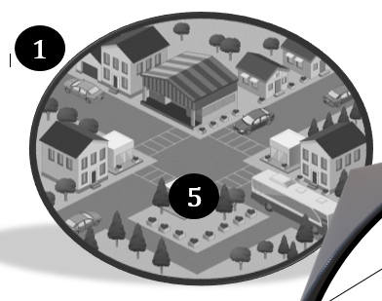  Where is my house on the map? | When writers or speakers establish context, they “situate” or “position” an argument in a way that communicates where it fits in the larger conversation.  This section of an argument is often referred to as an introduction. ESTABLISHING CONTEXT is what an introduction should do. | Ways that a topic might be “situated” or “contextualized”:  - historically  - socially  - through defining or informative information  - sharing the scope of the problem.
2. Stating Your Thesis  What is my purpose for building this house? | After providing context for the subject, the writer/speaker states their purpose for the essay in a thesis statement.  Chances are, a lot of the writing instruction you have received in the past few years has emphasized the creation of thesis statements. There is a good reason for this. Your thesis clearly communicates your purpose for writing or speaking. | Sometimes an author introduces readers to their line of reasoning in their thesis statement (closed thesis), other times, the line of reasoning is presented as it is developed in the essay (open thesis).
3. Developing a Line of Reasoning  How am I guiding my reader through my main points? (Think of it like a serious of stops along a route. Make sure you order them correctly.) | The line of reasoning in an argument refers to the arrangement of claims and evidence that leads to a conclusion.  Another way to think of line of reasoning: the communication of a writer/speaker’s train of thought.  It is important to EVALUATE the line of reasoning in an argument: if an argument’s purpose/thesis is not substantiated by a logical line of reasoning, it is not a valid argument. | WORDS THAT MIGHT SIGNAL A LINE OF REASONING WITHIN AN ARGUMENT:  Because, since, and then, besides, equally important, finally, further, furthermore, next, what's more, moreover, in addition, yet, on the other hand, however, nevertheless, on the contrary, by comparison, where, compared to, although, conversely, meanwhile, in contrast, although this may be true because, for, since, furthermore, moreover, in addition
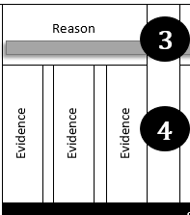  4. Evidence  What is supporting my claims/house? | Each claim in an argument’s line of reasoning must be backed by credible evidence from other sources. | VERBS THAT INTRODUCE EVIDENCE:  states, asserts, claims, agrees, concurs, disputes,
5. Significance  Why does this argument deserve to be part of a scholarly conversation? | Good arguments end with a concluding section that articulates the important way the argument has contributed to a scholarly dialogue. | This often takes the form of offering a solution or asking readers to take actions that will prompt positive change toward a solution.

