Unit 2: Poverty in America
Stimulus Packet

Context from the US Census Bureau
- The official poverty rate in 2018 was 11.8 percent, down 0.5 percentage points from 12.3 percent in 2017. This is the fourth consecutive annual decline in poverty. Since 2014, the poverty rate has fallen 3.0 percentage points, from 14.8 percent to 11.8 percent.
- In 2018, for the first time in 11 years, the official poverty rate was significantly lower than 2007, the year before the most recent recession.
- In 2018, there were 38.1 million people in poverty, approximately 1.4 million fewer people than 2017.
- Between 2017 and 2018, poverty rates for children under age 18 decreased 1.2 percentage points from 17.4 percent to 16.2 percent. Poverty rates decreased 0.4 percentage points for adults aged 18 to 64, from 11.1 percent to 10.7 percent. The poverty rate for those aged 65 and older (9.7 percent) was not statistically different from 2017.
- From 2017 to 2018, the poverty rate decreased for non-Hispanic Whites; females; native-born people; people living in the Northeast, Midwest, and West; people living inside metropolitan statistical areas and principal cities; people without a disability; those with some college education; people in families; and people in female householder families.
- Between 2017 and 2018, people aged 25 and older without a high school diploma was the only examined group to experience an increase in their poverty rate. Among this group, the poverty rate increased 1.4 percentage points, to 25.9 percent, but the number in poverty was not statistically different from 2017.

This packet provides a variety of sources, representing diverse topics, perspectives and lenses, to prompt QUESTIONING, EXPLORATION, UNDERSTANDING and ANALYSIS about this important topic. As you EVALUATE THE MULTIPLE PERSPECTIVES in the following documents, consider the following:
- What is the current status of poverty in America?
- What are some possible causes for poverty?
- What can be done to help the poor?

A U.N. investigation offers a stark assessment of poverty in America
Source 1
Genre:
Lens:
Essentially alone among its peer states in the West, the United States, despite its wealth and advanced technology, has maintained a policy of prolonged indifference to conditions of poverty that is thwarting the advancement of millions of its citizens. That was the stark assessment of Philip Alston, the special rapporteur on extreme poverty and human rights for the United Nations, in a report issued after the completion of a fact-finding mission in December.
Infant mortality in the United States is "the highest in the developed world"; and owing to inadequate sanitation, "neglected tropical diseases are making a comeback," he told reporters in Washington on Dec. 15. Because of its failure to provide universal health care and its market-driven model of health care delivery, "Americans can expect to live sicker and shorter lives," he said, than the citizens of any other advanced economy. Youth poverty in the United States is the highest among the nations of the Organization for Economic Co-operation and Development, "the rich countries' club," he added, and "the United States ranks 35 out of 37 in the O.E.C.D. in terms of poverty and inequality."
Mr. Alston visited pockets of poverty around the country in Alabama, California, Puerto Rico and West Virginia. Much of what he encountered came as a personal shock, he said, measured against the overall wealth of American society.
People in the United States often speak of its egalitarianism and American exceptionalism. They take pride in "the American dream," he said. But, he warned, "a child who is born into poverty has almost no chance to move out of poverty in the United States today."
Not far from the site of his press conference, final discussions were taking place on a tax plan that could ultimately mean greater burdens on the poor even as it directs more wealth into the hands of the nation's richest people. "For a country able to transfer a trillion dollars to its wealthiest not to be talking about taking care of basic health needs is stunning," he said.
According to international law, he said, "every person has the right to an adequate standard of living and where that seems impossible, it is the role of government to assist them." A significant challenge to human rights in the United States emerges out of the problem of unaddressed needs. "I believe that current trends in the United States are actually undermining democracy," Mr. Alston said. "What we see are the lowest voter turnouts in any developed country; we see overt efforts to disenfranchise people."
Ultimately the poor in the United States, he warned, are unable to significantly contribute to the political process or influence the policies that affect their lives. A criminalization of poverty through civil fines and penalties and harassment of the homeless, he argued, further exacerbates their disenfranchisement.
The poor in the United States, more than 40 million people, according to the Census Bureau, could easily be able to lead lives with dignity if minimal social commitments were met, according to Mr. Alston. "Surely it's the obligation of a society to ensure basic goods," he said, pointing out that the poor in America also struggle to get dental care and access mental health services, two other major obstacles to finding the jobs that could lift them out of poverty.
Many of the homeless he met, he said, were suffering from mental health problems or were U.S. military veterans struggling in the aftermath of their service. "In a country like the United States, homelessness could be eliminated pretty quickly." This is not being done, he said, because Americans simply "don't want to put the money into it."
Kevin Clarke, chief correspondent. Twitter: @ClarkeAtAmerica.
Caption: Homeless people organize their belongings in Washington in June 2017.
Please Note: Illustration(s) are not available due to copyright restrictions.
Copyright: COPYRIGHT 2018 America Press, Inc.. All rights reserved.
http://americamagazine.org/
Source Citation (MLA 8th Edition)
Clarke, Kevin. "A U.N. investigation offers a stark assessment of poverty in America." America, 8 Jan. 2018, p. 16+. Gale In Context: U.S. History, https://link.gale.com/apps/doc/A524663894/GPS?u=mlin_s_weyhs&sid=GPS&xid=162f5758. Accessed 30 Sept. 2019.
Gale Document Number: GALE|A524663894

Can poverty in America be compared to conditions in the world's poorest countries?
Source 2
Genre:
Lens:
Abstract:
Some contend that the American poor are affluent by international standards, and recent survey evidence finds that Americans have deeply divided views about the conditions faced by the poor in this country. To what extent can poverty in the United States be compared to conditions in the world's poorest nations? Few analysts have examined this question beyond "instrumental" measures of poverty such as income and consumption that only indirectly capture well-being. The current paper compares world statistics with available U.S. evidence to examine this question based on four direct indicators of wellbeing: 1) life expectancy; 2) infant mortality; 3) risk of homicide, and 4) risk of incarceration. By these metrics, well-being is highly stratified in the U.S. by income, education, and race. In 2008, life expectancy for low-educated African American males was equivalent to that observed in Pakistan, Bhutan, and Mongolia. In 2011, the infant mortality rate for non-Hispanic African Americans ranked below that of Tonga and Grenada. In 2012, cities in the U.S. with populations of more than 200,000 and poverty rates above 25% had an average homicide rate that would make them the 19th deadliest place in the world. In 2010, the incarceration rate for African American males was 4,347 per 100,000 of the national population, which has no international comparison. Consistent across all four indicators, among Americans at the bottom of the economic ladder, quality of life looks similar to what is experienced in countries with per-capita economic output that is a small fraction of that in the U.S.
Background
Some have argued that America's poor "live better than most of the rest of humanity." Furthermore, the nation is deeply divided in regards to the conditions faced by poor Americans. A recent survey by the Pew Research Center found that a majority of middle-to-upper income Americans agreed with the statement "poor people today have it easy because they can get government benefits without doing anything in return." In contrast, nearly two-thirds of low-income Americans agreed that "poor people have hard lives because government benefits don't go far enough to help them live decently" (Krogstad and Parker, 2014).
All this raises the very basic question of whether poverty in the U.S. can be compared to poverty in the world's poorest countries. Do poor Americans look rich or poor by international standards? In terms of rates of consumption, there is little doubt that the American poor on average are better off than the poor in the world's poorest countries. Poor Americans often live in larger homes and have access to goods that are luxuries in other parts of the world. Yet measures of consumption and income are but indirect markers of a person's well-being. A person might have a high level of consumption but low quality of life. Different societal standards might necessitate different patterns of consumption to allow basic human functioning, and certain forms of consumption may actually decrease quality of life.
Sen (1999) argues that to truly answer this question requires us to move beyond "instrumental" measures of well-being, such as income or consumption, and consider direct indicators of quality of life. In that spirit, below we compare the circumstances of America's poor to conditions in some of the world's poorest countries, using four direct measures of well-being for which available data allow international comparison. Our analysis treats the American poor--or sub-populations of disadvantaged Americans as available data require--as a "country," comparing them to the countries of the world to see where they rank. Our four markers of well-being are: 1) life expectancy; 2) infant mortality; 3) risk of homicide, and 4) risk of incarceration. There may be numerous other metrics that could be included, but we contend that most would agree that length of life, health of one's children, physical safety, and personal freedom are four salient metrics of quality of life that supersede access to consumable goods.
Life Expectancy
Life expectancy is defined as the average number of years a newborn in a given country is expected to live if mortality rates at each age were to remain at their current level. Over the last thirty years, Americans have experienced an increase in life expectancy, rising from 73.6 years at birth in 1980 to 78.5 years in 2010 (World Bank, 2014). However, the growth is not homogeneous across geography and demographic groups. A recent study by Chetty et al. (2016) shows that between 1999 and 2014, life expectancy increased by more than two years for men and women in the top 5% of the income distribution, but by less than 0.5 years for men in the bottom 5% and less than 0.1 years for women in the bottom 5%. This uneven growth in life expectancy has further widened the gap in life expectancy between the richest and the poorest Americans. Similar findings on a widening gap between income groups has been reported in earlier research (Waldron, 2013; Duggan, Gillingham, & Greenlees, 2008; Bosworth, Burtless, & Zhang; 2016).
If we look at disparities by geographic areas, Singh and Siahpush (2006) reports a widening gap in life expectancy between the most affluent and the most deprived U.S. counties from 1980 to 2000. In the study, U.S. counties were sorted into deciles based on a deprivation index constructed from indicators of education, occupation, wealth, income distribution, unemployment, poverty, and housing quality. In 1980-82, the absolute difference in life expectancy at birth between counties in the bottom and top deciles was 2.8 years. By 1998-2000, the gap had widened to 4.5 years. The most deprived counties are disproportionately concentrated in southern states, while the most affluent ones are mostly in the northeast and west.
We compare these results to World Health Organization statistics on life expectancy at birth by country and year. In 1998-2000, the poorest decile of counties in the U.S. had an estimated overall life expectancy at birth of 74.7 years. This figure is comparable with the life expectancy observed in year 2000 in Bahrain, the United Arab Emirates, and below that in Mexico (WHO, 2014).
Significant disparities in life expectancy can also be seen on the basis of educational status and race in the United States (Meara, Richards, & Cutler, 2008; Olshansky et al., 2012; Bosworth, Burtless, and Zhang, 2016). In 2008, the life expectancy at birth of highly-educated white males was 80 years, but it was only 66 years for low-educated African American males. Life expectancy was 84 years for the highly-educated white women, and 74 years for African American females with low educational levels, a difference of 10 years (Olshansky et al., 2012). Figure 1 shows that while the life expectancy of highly-educated whites compares favorably with countries with similar GDP levels, the life expectancy of low-educated blacks is of the same level of much poorer countries. In 2008 life expectancy for low educated African American males was equivalent to that observed in 2008 in Pakistan, Bhutan, and Mongolia (World Bank, 2014).
Infant Mortality
The infant mortality rate (IMR) is defined as the number of infants who die before reaching one year of age, per 1,000 live births in a given year. In 2013, the U.S. IMR was 5.9 per 1,000 live births, ranked 51st internationally (World Bank, 2014). Yet this figure masks serious racial and socio-economic disparities. In 2011, the IMR for non-Hispanic African Americans was 11.5, compared with 5.1 for non-Hispanic whites. A nation with an IMR of 11.5 would have ranked 77th internationally in 2011, just below Tonga and Grenada.
A recent finding by Oster and Williams (2014) shows that the post-natal mortality rate of infants born to white, college-educated, married women in the U.S. is comparable to similar advantaged demographics in selected high-income European countries. However, unlike the U.S., the mortality rates across differentially-advantaged sub-populations do not vary much for the comparison countries. In other words, the cross-country difference between U.S. and its peers is driven by the tremendous within-country disparities in the U.S.
Risk of Homicide
Past research has indicated that the homicide rate, defined as number of homicides per 100,000 persons, is associated with income disparities within a country (UNODC, 2011). In 2012, the homicide rate in the U.S. was 4.7 which ranked 128th internationally. The rate is significantly higher than that of countries with similar GDP per capita, such as Canada (1.6) and Finland (1.6). Countries with comparable homicide rates to the U.S. included Cuba, Albania, Yemen, and Niger.
It is not possible to examine the homicide rate experienced by the nation's poor, but one can construct such a rate for the nation's poorest cities. If one examines large cities in the United States with populations of more than 200,000, and restricts to cities with a poverty rate above 25%, the resulting group would have a population of 8.4 million people and a homicide rate of 24.4 per 100,000. Among all nations, this homicide rate would rank this collection of cities the 19th most deadly place in the world, slightly less dangerous than Colombia (30.8) and Brazil (27), and more dangerous than the Dominican Republic (22.1). Figure 3 shows how these high poverty cities and the United States compared to other countries.
Risk of Incarceration
The U.S. has the highest incarceration rate in the world, defined as the number of prisoners per 100,000 of the national population. In 2011, the rate was 716 per 100,000 in the U.S, well above all other countries including Barbados (521), Cuba (510), and Rwanda (492) (Walmsley, 2012). There is no clear relationship between the incarceration rate and the economic prosperity of a country with both the Scandinavian countries and the western African countries having the lowest incarceration rates in the world.
However, the burden of high incarceration rates in the U.S. does not fall equally. As of 2010, the incarceration rate for African American males was 4,347 per 100,000 of the national population, compared with 678 for white males, 260 for African American females, and 97 for white females (Glaze, 2011). The incarceration rate for African American males has no international comparison as Figure 4 clearly shows. Even amongst white male Americans, the incarceration rate is much higher than the next highest country--Rwanda.
Research by Pettit & Western (2004) further looks into class inequality in incarceration rates by examining imprisonment disparities by education level and race. They find that incarceration is highly stratified not only by race, but also by education. For white male high school dropouts born 1965 to 1969, 11.2% will serve prison time before age 35, compared with 3.6% for white male high school graduates and 0.7% for people with some college education. The cumulative risk is 58.9% for African American male high school dropouts, 18.4% for high school graduates and 4.9% for people with some college education. For an African American male who does not complete high school, it is more likely than not he would have served some prison time by age 35.
Where Do the American Poor Stack Up?
There is considerably disagreement about the severity of the conditions facing America's poor. Some argue that they are affluent by international standards. Can poverty in the U.S. really be compared to what is experienced in the world's poorest countries?
In an attempt to offer evidence on this question, the current paper builds on Sen (1999) and moves beyond "instrumental" measures of well-being such as income and consumption to identify four direct indicators of wellbeing or quality of life. We then ask how poor Americans fare on these measures relative to those living in the world's poorest countries. In all four domains, America's poor rank far lower than what is seen in the most affluent countries, and instead find themselves in the company of countries with just a fraction of the GDP of the United States. Some groups of disadvantaged Americans have a life expectancy that parallels that of Bahrain while others have life expectancy similar to what is experienced in Mongolia. African Americans face an infant mortality rate comparable to that of Tonga and Grenada. The homicide rate in America's large and very poor cities is slightly higher than that of Rwanda, and slightly lower than that of Colombia. Finally, disadvantaged Americans are more likely to lose their freedom to incarceration than the population of any other country in the world. By these metrics, it is not at all clear that the poor are wealthy by global standards. In fact, their circumstances look quite poor indeed.
doi: 10.22381/AJMR4120176
Received 7 October 2016 * Received in revised form 10 January 2017
Accepted 10 January 2017 * Available online 25 January 2017
REFERENCES
Bosworth, B., G. Burtless, and K. Zhang (2016), Later Retirement, Inequality in Old Age, and the Growing Gap in Longevity between Rich and Poor. Washington, DC: Brookings Institution
Chetty, R., M. Stepner, S. Abraham, S. Lin, B. Scuderi, N. Turner, A. Bergeron, and D. Cutler (2016), "The Association between Income and Life Expectancy in the United States, 2001-2014," JAMA 315(16): 1750-1766.
Duggan, J. E., R. Gillingham, and J. Greenlees (2008), "Mortality and Lifetime Income: Evidence from US Social Security Records," IMF Staff Papers 55(4): 566-594.
Glaze, L. E. (2011), Correctional Populations in the United States, 2010. U.S. Department of Justice, http://bjs.ojp.usdoj.gov/content/pub/pdf/cpus10.pdf.
Krogstad, J. M., and K. Parker (September 16, 2014), Public Is Sharply Divided in Views of Americans in Poverty. Factank: Pew Research Center. http://www.pewresearch.org/fact-tank/2014/09/16/ public-is-sharply-divided-in-views-of-americans-in-poverty
Meara, E. R., S. Richards, and D. M. Cutler (2008), "The Gap Gets Bigger: Changes in Mortality and Life Expectancy, by Education, 1981-2000," Health Affairs 27(2): 350-360.
Olshansky, S. J., T. Antonucci, L. Berkman, R. H. Binstock, A. Boersch-Supan, J. T. Cacioppo, ... J. Rowe (2012), "Differences in Life Expectancy Due to Race and Educational Differences Are Widening, and Many May Not Catch Up," Health Affairs 31(8): 1803-1813. doi:10.1377/hlthaff.2011.0746
Oster, E. F., and H. Williams (2014), "Why Is Infant Mortality Higher in the US than in Europe?" NBER Working Paper 20525.
Pettit, B., and B. Western (2004), "Mass Imprisonment and the Life Course: Race and Class Inequality in US Incarceration," American Sociological Review 69(2): 151-169.
Sen, A. (1999), Development as Freedom. Oxford and New York: Oxford University Press.
Singh, G. K., and M. Siahpush (2006), "Widening Socioeconomic Inequalities in US Life Expectancy, 1980-2000," International Journal of Epidemiology 35(4): 969-979. doi: 10.1093/ije/dy1083
The World Bank (2014), Infant Mortality Rate [Data file]. http://data.worldbank.org/indicator/SP.DYN.IMRT.IN
The World Bank (2014), Life Expectancy at Birth [Data file]. http://data.worldbank.org/indicator/SP.DYN.LE00.IN
The World Health Organization (2014), Life Expectancy by Country [Data file]. http://apps.who.int/gho/data/node.main.688
United Nations Office on Drugs and Crime, Vienna International Ctr, and Austria (2011), Global Study on Homicide 2011.
Waldron, H. (2013), "Mortality Differentials by Lifetime Earnings Decile: Implications for Evaluations of Proposed Social Security Law Changes," Social Security Bulletin 73(1): 1-37.
Walmsley, R. (2012), World Prison Population List. 10th edn. International Centre for Prison Studies, King's College London, School of Law. http://www.apcca.org/uploads/10th_Edition_2013.pdf
Copyright: COPYRIGHT 2017 Addleton Academic Publishers
http://www.addletonacademicpublishers.com/
Source Citation (MLA 8th Edition)
Shaefer, H. Luke, et al. "Can poverty in America be compared to conditions in the world's poorest countries?" American Journal of Medical Research, vol. 4, no. 1, 2017, p. 84. Gale Academic OneFile, https://link.gale.com/apps/doc/A494100253/GPS?u=mlin_s_weyhs&sid=GPS&xid=09569dc8. Accessed 30 Sept. 2019.
Gale Document Number: GALE|A494100253

Poor America; Poverty in America.
Source 3
Genre:
Lens:
Government programmes have done more to help poor Americans than is widely acknowledged. The best way to build on them is to focus on children, says Idrees Kahloon
ELDERLY RESIDENTS of Inez, the tiny seat of Martin County, Kentucky, deep in the heart of Appalachia, can still vividly remember the day the president came to town. Fifty-five years ago, while stooping on a porch, Lyndon Johnson spoke at length to Tom Fletcher (pictured), a white labourer with no job, little education and eight children. "I have called for a national war on poverty," Johnson announced immediately afterwards. "Our objective: total victory." That declaration transformed Fletcher and Martin County into the unwitting faces of the nation's battle, often to the chagrin of local residents who resented the frequent pilgrimages of journalists and photographers. The story never changed much: Fletcher continued to draw disability cheques for decades and never became self-sufficient before his death in 2004. His family continued to struggle with addiction and incarceration.
Today Martin County remains deeply poor--30% of residents live below the official poverty line (an income of less than $25,750 a year for a family of four). Infrastructure is shoddy. The roads up the stunning forested mountains that once thundered with the extraction of coal now lie quiet, cracked to the point of corrugation. Problems with pollution because of leaky pipes mean that some parts of the county are without running water for days. "Our water comes out orange, blue and with dirt chunks in it," says BarbiAnn Maynard, a resident agitating for repairs. She and her family have not drunk the water from their taps since 2000; it is suitable only for flushing toilets. Some residents gather drinking water from local springs or collect rainwater in inflatable paddling pools.
The ongoing poverty is not for lack of intervention. The federal government has spent trillions of dollars over the past 55 years. Programmes have helped many. But they also remain fixated on the problems of the past, largely the elderly and the working poor, leaving behind non-working adults and children. As a result, America does a worse job than its peers of helping the needy of today. By the official poverty measure, there were 40m poor Americans in 2017, or 12% of the population. This threshold is extremely low: for a family of four, it amounts to $17.64 per person per day. About 18.5m people have only half that amount and are mired in deep poverty. Children are the likeliest age group to experience poverty--there are nearly 13m of them today, or 17.5% of all American children.
In international comparisons, that makes America a true outlier. When assessed on poverty relative to other countries (the share of families making less than 50% of the national median income after taxes and transfers), America is among the worst-performing in the OECD club of mostly rich countries (see chart on next page). Despite its higher level of income, that is not because it starts with a very large share of poor people before supports kick in--it is just that the safety net does not do as much work as elsewhere. On this relative-poverty scale, more than a fifth of American children remain poor after government benefits, compared with 3.6% of Finnish children.
Child poverty often leads to adult poverty and all of its problems: psychological distress, exposure to crime and lost productivity. The National Academies of Sciences, Engineering and Medicine, in a new 600-page study on the subject, estimate that child poverty costs America between $800bn and $1.1trn annually because of lost earnings and greater chances of criminality and poor health.
How can one of the richest countries in the world have so many poor people, and what can be done about it? This special report will aim to answer these questions. It will show how poverty is shifting geographically from cities to suburbs and examine the continuing influence of race. It will consider philanthropy and private enterprise. And it will conclude by arguing that heftier anti-poverty spending on children is the best way to make a difference.
For those who disparage the trillions of dollars spent on safety-net programmes as a well-intentioned but quixotic endeavour, the case of Martin County would seem a clear cautionary tale. "We waged a war on poverty, and poverty won," Ronald Reagan lamented while president. That fatalism remains alive and well in American politics--from both the right, which often sees poverty as an inescapable problem of character and choice that is impervious to government intervention, and much of the left, which increasingly sees it as an inescapable consequence of predatory capitalism. Both strains of pessimism are simplistic and incorrect. Now, as then, solutions do not adhere neatly to liberal or conservative agendas. The left has, in the past, overemphasised the ability of the government to achieve change. The right, mistrustful of state intervention and too convinced that a free market will automatically bring universal well-being, has done little creative thinking.
Because of this, the politics of poverty have become stuck. America is bogged down in the interminable exercise of separating the deserving poor from the undeserving. Treating the poor as responsible for their predicament is callous; treating them as victims of social structures and bad circumstances robs them of agency and dignity. Fair-minded people can find themselves anywhere in between. Moreover, settling the debate over personal responsibility is also impossible, at least to the satisfaction of the most committed ideologues. A person who is convicted of a violent felony--a blameworthy choice--could face years of penury, but their childhood in a poor, segregated neighbourhood with little support from school or family--unlucky circumstances--are likely to have contributed to that action.
The partisan debate is focused on whether able-bodied, working-age adults should receive cash handouts. Yet such adults are a minority of the poor population today. Only a small number of them report unemployment or voluntary non-participation in the labour force. Straightforward cash welfare for non-working mothers--the battleground of the Clinton-era debate--is now only a small part of the safety net compared with in-kind programmes (like food stamps or Medicaid, the government health-insurance programme for the poor) and tax credits that boost the wages of the working poor. The main conduits of direct cash are disability payments and Social Security for the elderly which, by definition, do not go to able-bodied adults.
Some see the continued existence of deprivation in America as a reason to shrink the safety net, believing it to have been ineffective. Yet poverty persists today not because of the failure of the net, but in spite of its widespread impact. The correct way to evaluate the success of anti-poverty programmes is counterfactually. The question is not whether poverty still exists, but how much worse it would be without government action. Answering that is made harder by the arcane way in which America measures poverty. The official level relies on pre-tax income, disregarding aid from safety-net programmes and differences in living expenses, making improvements difficult to register.
When a better tool is used--the supplemental poverty measurement (SPM), which takes these deficiencies into account--the effect of the expanded safety net becomes clear (see box on next page). In 1967 safety-net taxes and transfers barely dented poverty: 26.4% of Americans were poor before, and 25% remained poor after. Without a safety net, nearly the same proportion of Americans, 24.6%, would be poor today as were 50 years ago.
Yet because of greatly expanded anti-poverty programmes, such as food stamps and the earned-income tax credit, which tops up the wages of low-paid Americans, only 13.9% are poor after taxes and transfers. The elderly were once among the poorest groups--and still would be were it not for the old-age cash and health benefits provided by Social Security and the Medicare programme. Now, they do about as well as working-age adults.
Eastern Kentucky exemplifies the evolving nature of poverty in America since Johnson declared his war. Compared with the rest of the country, poverty there remains high. But in absolute terms, the share of poor residents has dropped by nearly half since 1960. When John F. Kennedy campaigned for the presidency in West Virginia, he was horrified not by the state of the roads but by the emaciated people. Out-and-out hunger is much rarer today. However, new social pathologies have sprung up: obesity, joblessness, disability and addiction.
Each new social problem compounds the others. Individual choice and social structure co-mingle, yielding a Gordian knot of pathology difficult for policymakers to cut. The national economy has evolved to one that prizes education, leaving low-skilled workers behind. Deindustrialisation and incarceration have particularly decimated the prospects for black men.
Poor families of all races have become increasingly unstable as a result. Rates of non-marriage and births out of wedlock have risen among this population, leading to many more single-mother families--41% of children in such households live below the poverty line. Drug use, particularly of opioids, has grown exponentially, fracturing families even more. "I became a mother at 72 again," says Debbie Crum, who has lived nearly all her life in Martin County. "My great-nephew and his girlfriend had the baby. But they were hooked on drugs. The family had to go all the way back to me before they could find someone who could take care of the baby, who could pass the background check and drug test." Ms Crum is a loving carer, but not all children are so lucky.
The Bureau of Economic Analysis publishes detailed data on sources of income, public and private. In some counties of Kentucky, federal transfers--through food stamps and disability and old-age benefits--account for 36% of all income. Without them, crises like joblessness and drug addiction would be far worse. Hospitals, schools and local government are often the largest providers of stable jobs. Medicaid, which was expanded in Kentucky through Obamacare, pays for substance-abuse treatment in parts of America hit hardest by the opioid epidemic.
The existence of poverty does not undermine the American dream, but the persistence of it does. The safety net looks stuck in time, even though the problem of poverty has evolved. And now there is a new danger. Because of rising income inequality and housing costs, poverty is moving out of cities and into suburbs, where it is less visible. Poor white and Hispanic Americans are much more likely to live in such places. Combating this looming problem is not at the heart of any political agenda. That is unfortunate and self-defeating. A wealth of economic and sociological studies show that poor children who grow up in districts of concentrated poverty have profoundly worse life outcomes--their incomes sag, their health deteriorates and their family lives turn dysfunctional. The job of the safety net is to arrest this cycle. If this generation of poor children is to do better than the one before, the net will need to become stronger still.
Copyright: COPYRIGHT 2019 Economist Intelligence Unit N.A. Incorporated
http://store.eiu.com/
Source Citation (MLA 8th Edition)
"Poor America; Poverty in America." The Economist, 28 Sept. 2019, p. 6(US). Gale OneFile: Business, https://link.gale.com/apps/doc/A600826668/GPS?u=mlin_s_weyhs&sid=GPS&xid=64333eef. Accessed 30 Sept. 2019.
Gale Document Number: GALE|A600826668

Fences
BY PAT MORA
Source 4
Genre:
Lens:
Mouths full of laughter,
the turistas come to the tall hotel
with suitcases full of dollars.

Every morning my brother makes
the cool beach new for them.
With a wooden board he smooths
away all footprints.

I peek through the cactus fence
and watch the women rub oil
sweeter than honey into their arms and legs
while their children jump waves
or sip drinks from long straws,
coconut white, mango yellow.

Once my little sister
ran barefoot across the hot sand
for a taste.

My mother roared like the ocean,
“No. No. It’s their beach.
It’s their beach.”

Poem copyright ©1991 by Pat Mora, whose most recent book of poetry is “Adobe Odes,” University of Arizona Press, 2007. Poem reprinted from “Communion,” Arte Publico Press, University of Houston, 1991, by permission of the writer and publisher.

Mora, Pat.
My own true name.
Houston, Tex. : Piñata Books, 2000

Trump's vitally important anti-poverty initiative
Source 5
Genre:
Lens:
It takes a lot of courage for a president to target almost a quarter of the federal budget for reform in an election year. But this is exactly what President Trump is doing with his executive order, "Reducing Poverty in America by Promoting Opportunity and Economic Mobility."
We're now spending more than $700 billion per year on low-income assistance, which is more than we are spending on our national defense. And there are plenty of reasons to believe this spending is inefficient, wasteful and counterproductive.
Over the last half-century, some $22 trillion has been spent on anti-poverty programs, and yet the percentage of poor in this nation remains unchanged. The Better Way report produced by the House speaker's office in 2016 reported that 34 percent of those born and raised in the bottom fifth of the income scale remain there all their lives.
The point has often been made that the greatest charitable gesture is teaching those in need to help themselves.
This principle defines the president's reforms to our anti-poverty programs and spending. Let's make sure that every dollar spent goes to those truly in need and that those dollars are spent to maximize the likelihood that the recipients will get on their feet and become independent, productive, income-earning citizens.
The executive order directs federal agencies to review the some 80 federal anti-poverty programs, consolidate where there is redundancy and overlap, and look to reform by applying the principles of hard work and self-sufficiency.
Needless to say, the usual left-wing megaphones, those that can't tell the difference between compassion and spending billions of other people's dollars, have wasted no time to go on attack.
The headline from the Southern Poverty Law Center screams, "Trump's executive order on work requirements punishes low-income people for being poor."
However, Robert Doar of the American Enterprise Institute reports that there are almost 20 million working-age Americans receiving benefits under Medicaid and food stamps who don't work.
The "Better Way" report notes that "44 percent of work-capable households using federal rental assistance report no annual income from wages."
But it's not just about work requirements.
Vital to this reform project is moving programs out of Washington's grasp and into the administrations at the state and local levels. Assistance programs need humanity and flexibility. This can only be done locally. There's no way an army of bureaucrats in Washington can develop and implement programs for 50 million needy individuals that can properly recognize what unique individuals need to move out of poverty.
Assistance programs need to promote and embody those principles that go hand in hand with prosperity-ownership, investment, savings and personal freedom and responsibility.
According to the Better Way report, almost 10 million Americans have no bank account and another 25 million have an account but get financial services outside of the banking system.
When I was a young woman on welfare, I saw the destruction that occurs when assistance programs penalize work, marriage and saving, as was the case with the Aid to Families with Dependent Children program. Subsequently, this was reformed and transformed with great success to the Temporary Assistance for Needy Families program.
We can't go on spending hundreds of billions of dollars of limited taxpayer funds on programs that may have been conceived with sincerity and compassion but don't work.
President Trump deserves credit for exercising the courage and vision to move to fix what is broken in our anti-poverty programs. It is vital for the poor and vital for the nation.
Copyright: COPYRIGHT 2018 Indianapolis Business Journal Corp.
http://www.ibj.com
Source Citation (MLA 8th Edition)
Parker, Star. "Trump's vitally important anti-poverty initiative." Indianapolis Business Journal, 27 Apr. 2018, p. 15B. Gale OneFile: Business, https://link.gale.com/apps/doc/A539324379/GPS?u=mlin_s_weyhs&sid=GPS&xid=37bb15cd. Accessed 30 Sept. 2019.
Gale Document Number: GALE|A539324379

Does work-for-welfare work? Employment requirements for government assistance are not as simple as proponents say
Source 6
Genre:
Lens:
Albert Einstein elegantly once said that the definition of insanity is doing the same thing over and over again but expecting different results. This adage comes to mind when we see that, yet again, work requirements are being used as a bludgeon to combat Americans who live in poverty and who are in need of safety-net programs like Supplemental Nutrition Assistance Program (SNAP), housing assistance, and, if President Trump has his way, even Medicaid.
The White House Council of Economic Advisers has recommended work requirements for the most extensive welfare programs and the current administration has mandated that federal agencies alter their presumably lax welfare program standards. These moves are premised on the continuing notion that the poor are a drain on federal resources due to their laziness, recklessness and lack of ambition. So here we go again - concluding that the poor are so solely because of their own deficient behavior and must be made to work harder to receive assistance from this government.
It's not that simple.
Is this work requirement approach fair in that recipients of aid (excluding children, elderly and disabled) should be made to show an attempt to earn their government supports, which allegedly incentives people to not be poor, or is this a kick to the poor and disenfranchised when they're already down?
It's worth examining a few of the points about welfare work requirements:
1. According to the U.S. Census Bureau, the 2017 poverty rate was 12.3 percent, a 0.4 percent decrease from the year before. Since 2014, the poverty rate has fallen 2.5 percent So if the current trend line is a declining poverty rate, why is a harsh condition like work requirements for the poor necessary at this time?
2. This effort was last tried under Bill Clinton and Newt Gingrich with their 1996 welfare reform legislation. We've had a couple of decades to see how that has gone, and studies like those from the Center on Budget and Policy Priorities and in the book "Making Ends Meet" (by Kathryn Edin and Laura Lein) show that despite short-term marginal improvements in employment they were not sustainable, mostly due to necessary and increased living expenses, absorbing any work-generated financial gains.
3. Where are these jobs that the poor are supposed to get? If you've spent most of your life in poverty, chances are quite low you can pick up a knowledge-economy job quickly. We've all heard how the traditional manual labor jobs are drying up, so what's left? Lousy-waged part-time jobs with unpredictable and changeable hours is what's left.
4. If the government feels the need to pick on somebody shouldn't it be the employers of vast numbers of unskilled and low-skilled who pay their workers, including the working poor, insufficient wages that in turn need to be underwritten by the American taxpayers?
One place where there could be political agreement is in the government providing subsidized, high-quality work training requirements targeted to actually helping the poor get the knowledge and skills needed for a globalized and digitized economy. Currently, training requirements can be in lieu of work requirements, but their effectiveness remains questionable.
The causes and cures for poverty are varied, complex and far beyond the scope of this piece. But if we as a society are truly interested in ameliorating the condition of poverty (as we should be!) we need to be looking for demonstrably beneficial interventions that measurably make positive differences.
Requiring the poor to get a low-end job that increases their child care and transportation costs just to prove they're not milking the system or making them pay for a hand up from those of us with taxpaying means is not a humane way to go about it.
BY BILL RYAN
Bill Ryan, founder of Ryan Career Services, Concord, can be reached at 603-724-2289 or bill@ryancareerservices.com.
Copyright: COPYRIGHT 2019 Business Publications, Inc.
Source Citation (MLA 8th Edition)
Ryan, Bill. "Does work-for-welfare work? Employment requirements for government assistance are not as simple as proponents say." New Hampshire Business Review, 1 Feb. 2019, p. 19. Gale OneFile: Business, https://link.gale.com/apps/doc/A575196699/GPS?u=mlin_s_weyhs&sid=GPS&xid=2be5a7db. Accessed 30 Sept. 2019.
Gale Document Number: GALE|A575196699

Catholic Charities launches new campaign to assist U.S. poor
Source 7
Genre:
Lens:
Seeking to create awareness about poverty in the United States and to stand in solidarity with Pope Francis' commitment to the poor, Catholic Charities USA has launched a new national campaign. Donna Markham, a Dominican sister, discussed the effort on Sept. 10 in her first address as president and chief executive officer of the organization during its national convention in Omaha. The campaign, called #End45--Raise a Hand to End Poverty in America, reflects the 45 million people in the United States who live in poverty. "That's scandalous," said Sister Donna, the organization's first female president.
The campaign is appearing online nationwide on member websites, Facebook, Twitter and other social media accounts, with videos of people who have been helped by Catholic Charities. In addition, people are encouraged to show support by taking a picture of their hand with "End45" written on their palm and post it to their social media channels using the hashtag"End45."
"We are asking our country to work with us to end 45," said Sister Donna. John Griffith, executive director of Catholic Charities of Omaha, said the local agency has long partnered with other organizations locally and nationally. The new campaign can help increase awareness about their efforts and allow them to help more people, he said.
Looking ahead to the Year of Mercy that begins in December, Sister Donna said, "We're ready to stand with [Pope Francis] as missionaries of mercy across this country and beyond."
At a news conference at the National Press Club on Sept. 17, less than one week before the pope was scheduled to arrive in the United States, Sister Donna said Pope Francis "serves as a powerful catalyst" for the change American society needs in its regard and treatment of the poor and vulnerable. Her remarks came one day after the Census Bureau issued its annual assessment of U.S. poverty. The new numbers are not only disheartening; they could mean Catholic Charities will have to recast its "#End45" branding.
The number of poor people in the U.S. in 2014, according to the Census Bureau, was 46.7 million, up from the previous year's figure of 45 million, which Catholic Charities used for its anti-poverty campaign. The 2014 number includes 15.5 million children. The Census Bureau said the size of the increase is not statistically significant.
Catholic Charities served nine million individual Americans last year through its 177 affiliates in the United States and its territories. As to how the other 36 million or more might have been helped, Sister Donna said, they may have been served by other agencies, but she suggested many merely fall through the cracks, unaware that help is available to them.
Sister Donna said she expected Pope Francis' address before a joint meeting of Congress on Sept. 24 to be "disturbing to everybody" sitting in the gallery, regardless of political party. "I have no idea what that man's going to say. It's going to be honest," she added, noting, "I'm sure he's going to make everybody a little uncomfortable."
It is possible that from that sense of discomfort policy solutions may arise to give the poor a genuine boost, Sister Donna said.
In the meantime, Sister Donna indicated that some corporate leaders had approached Catholic Charities about what they could do. Part of the solution lies in getting people through the day-to-day; she said 54 percent of Catholic Charities clients who visit for the first time do so because they are hungry.
But the second part of the equation is to give them a start that will allow them to shake off their poverty. Sister Donna cited the food and horticultural sectors of the economy as two that have a continual call for trained workers.
Source Citation (MLA 8th Edition)
"Catholic Charities launches new campaign to assist U.S. poor." America, 5 Oct. 2015, p. 10+. Gale In Context: U.S. History, https://link.gale.com/apps/doc/A436232187/GPS?u=mlin_s_weyhs&sid=GPS&xid=00844fec. Accessed 30 Sept. 2019.
Gale Document Number: GALE|A436232187
American Realities
Source 8
Genre:
Lens:

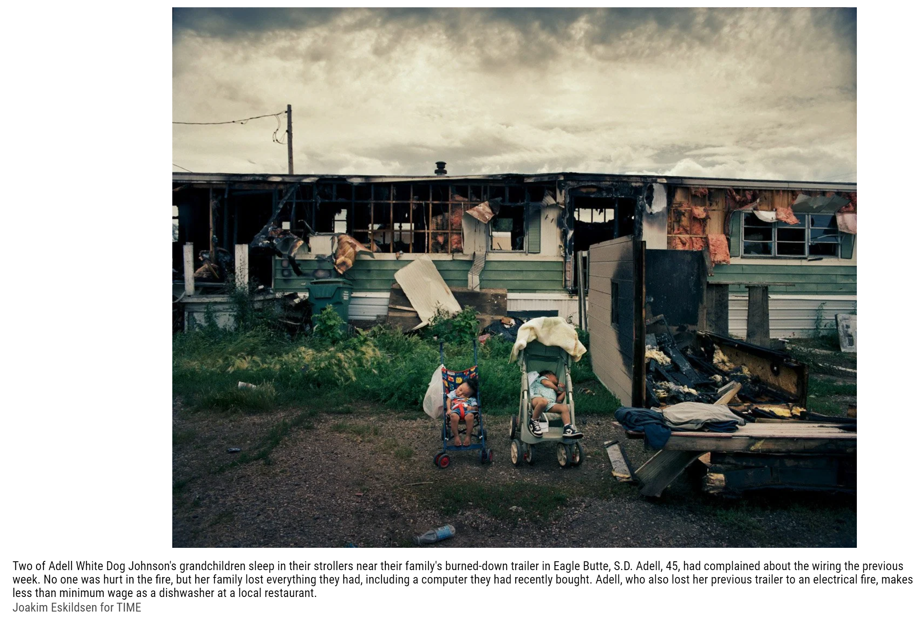
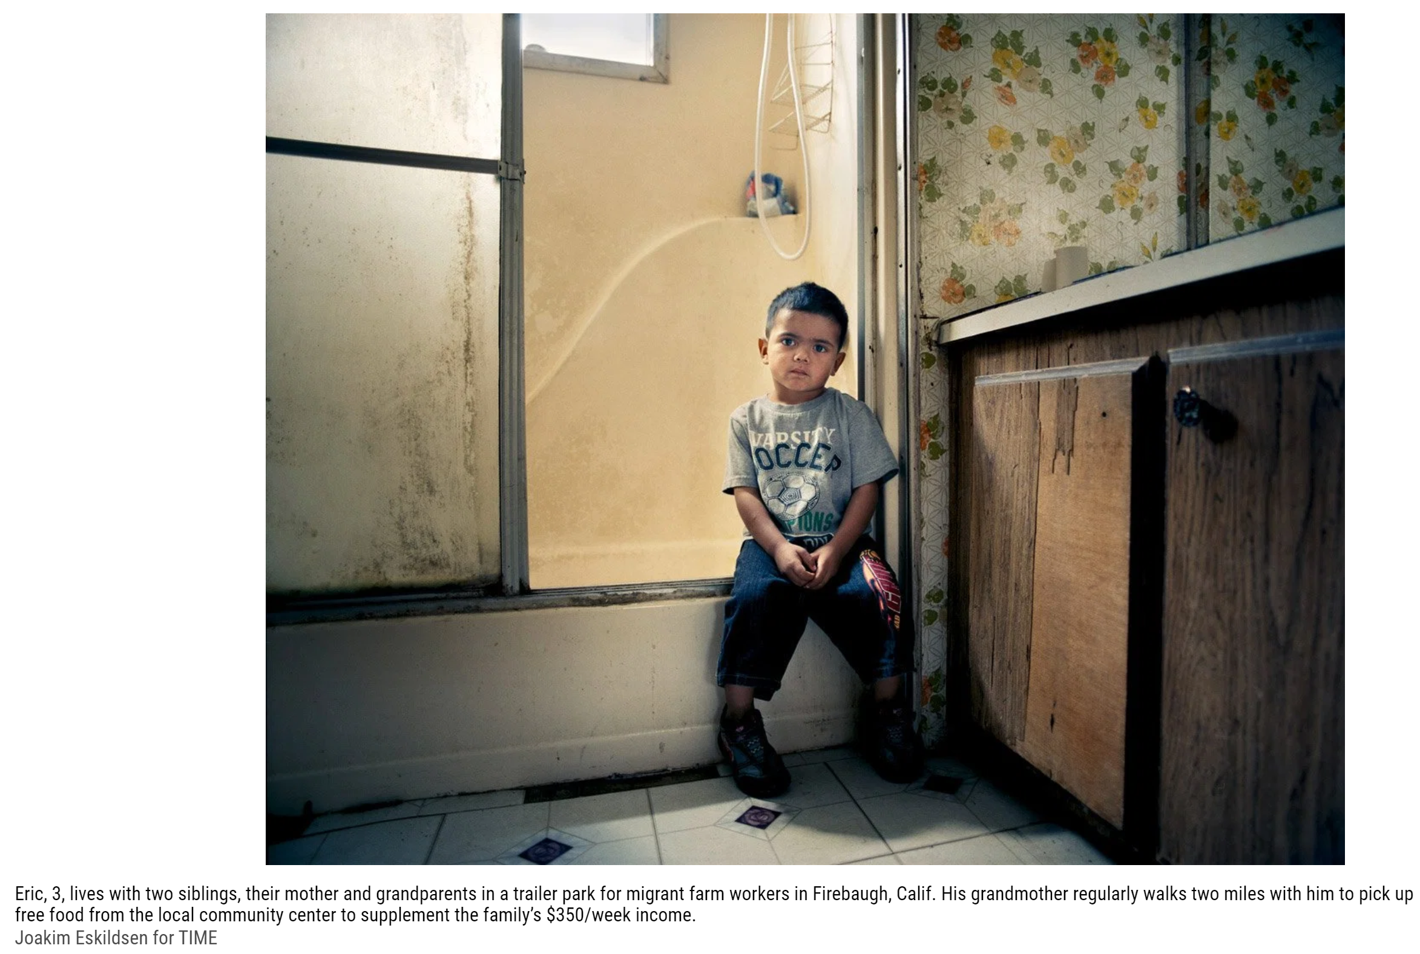
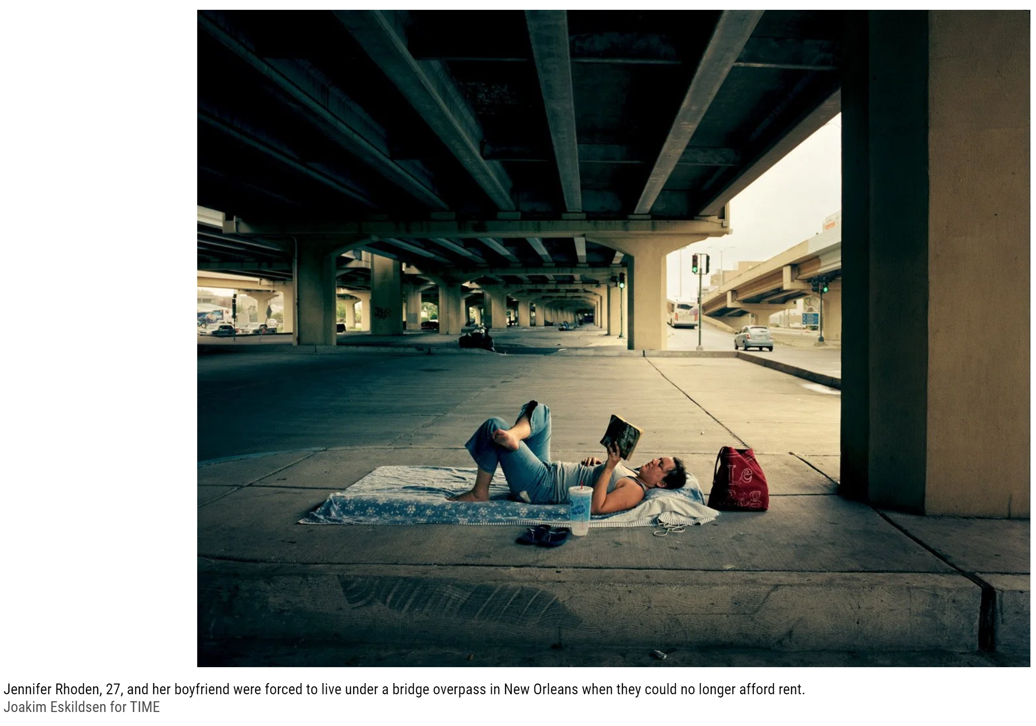

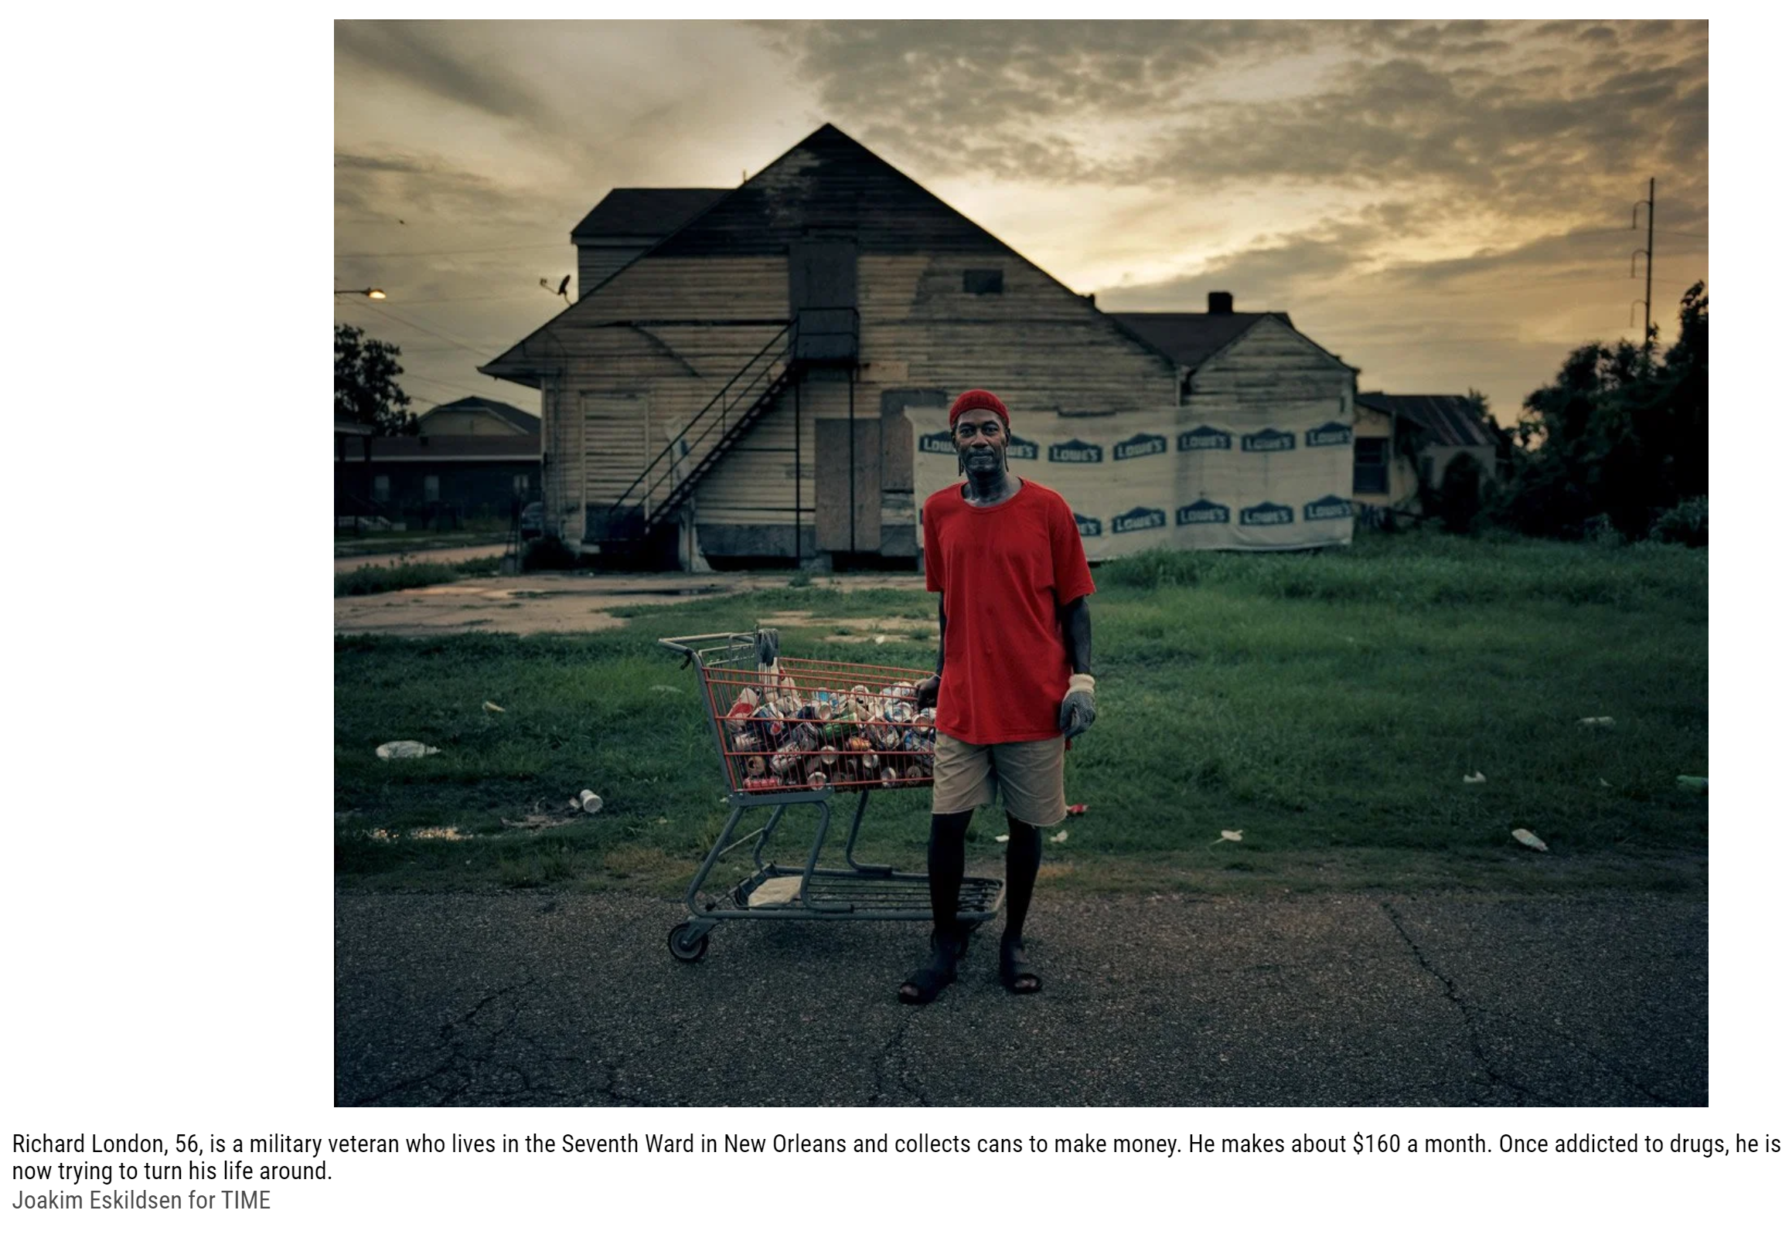
Eskildsen, Joakim. “Photographs of American Poverty by Joakim Eskildsen.” Time, Time, 17 Nov. 2011, https://time.com/3782964/below-the-line-portraits-of-american-poverty/.

