Individual Research Report
Rubric Feedback – Row 1
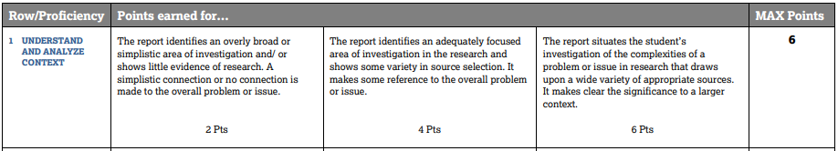

In this part of the rubric the key question is this: Is the area of investigation focused and situated in the student’s research? Graders are told to look at the Title, Works Cited and the intro paragraph
- The area of investigation is clearly stated and narrow enough to research. (Topic and Lens)
- Significance of the topic is made clear
- Shows that scholars are talking about it.
- Draws on scholarly sources (This means 10 for the real IRR (we said 4 for the mock IRR)

Below is a model introduction from a WHS AP Sem Scholar. It meets all four elements that help you get a 6 in this category and along with a works cited that had the required number of scholarly sources, scored a 6.

Social/Cultural Perspective on Illegal Immigrants Crossing the U.S.-Mexico Border
The ineffective system at the border between Mexico and the United States is a concerning source for inequality for immigrants in America. According to the United States Census Bureau and American Community Surveys, the number of Central American immigrants living in the United States increased by about 3,173,000 between 1980 and 2017 (Batalova, et al. 1). Francine D. Blau with Cornell University and other authors further recognized that “the unauthorized population also grew...from an estimated 5.7 million in 1995 to 11.1 million by 2014” (2). David Androff and Kyoko Tavassoli who have written for Oxford University have suggested that these immigrants are criminalized, which results in “human rights violations, including migrant deaths, processing of apprehended migrants in mass hearings, abuses in immigration detention, and inhumane deportation practices” (3). This literature review analyzes illegal immigration. It questions the poorly monitored border system by considering the social and cultural causes and various potential solutions. A careful evaluation of the research on the cultural and social aspects of this issue highlights the changing group of migrants, and emphasizes the importance of the struggles in the immigrant’s home countries, the journey they have to make, and how they are treated at the border

Tip: Consider using evidence in your intro to 1. establish the problem, 2. show its impact, and then 3. bring it down to your specific lens.

