Developing a Research Question
Developing a good research question is critical. Without one, you can end up picking a question that is too broad to be properly researched or does not allow for conversation between perspectives. In AP Seminar, good research questions:
- Require a judgment to be made (not just description)
- Are researchable (it is possible to find relevant and credible sources)
- Involve genuine points of ongoing debate (Invite engagement with alternative perspective)
- Simple
Helpful Steps
- Choose a topic of conversation. This topic should have a clear focus that will guide your research.
For this assignment what cause of poverty does your group want to research and talk about?
- Start developing a list of questions about this conversation you have decided to join. When developing your list, think about what you want to accomplish with your research. Your brainstorming questions should begin with words such as when, where, what and who.
As you start to think about potential answers to these questions write them down below.

Write your working question here:

Working Question

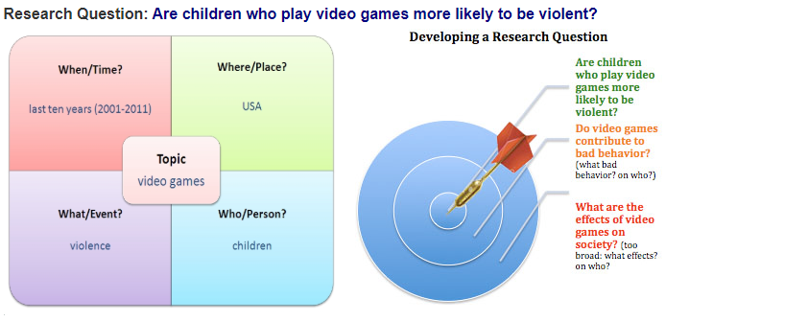
- Next, you will need to craft your research question so that it points you towards solutions. Instead of just asking Are children that play video games more likely to be violent? Push yourself to think about what SHOULD be done. Should US companies do a better job preventing children from buying violent video games?
Another EXAMPLE:
- Does having children adversely affect American women professionally? (weak – answer implied, too narrow)
- Should American businesses be required to provide six-month paid maternity leave? (stronger – no implied answer, provides an opportunity to build context, requires you to take a stance, allows you to quickly pivot to research-based solutions)
When writing research questions, revision is inevitable. You want to make sure your question requires a judgment to be made and a solution to be offered. You might not know enough about your topic to think of possible solutions. If you get stuck at this step, you might want to conduct some preliminary research. This is why we gave you the stimulus packet, but depending on your topic you might need more.
Research Question | Lens 1
 | Lens 2
 | Lens 3
 | Lens 4

Approved Yes or No : Signature _______________________________________________________________________

