Scholars uses multiple lenses to understand a topic.
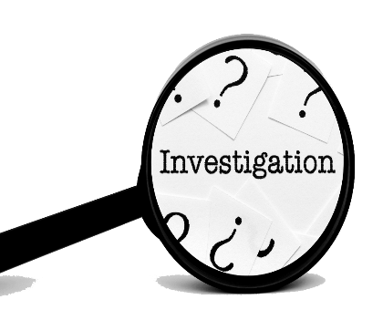
TOPIC
To understand any topic, you need to study it through multiple lenses.
Scholars find multiple perspectives (a point of view conveyed through an argument) WITHIN a chosen lens and analyze these perspectives before arriving at a judgment about the topic

Humanities Sciences

Educational
How does this impact students and how can learning help?
Artistic
What creative expressions can we use to explore this or raise awareness?

Historical
How have humans dealt with this in the past?
Ethical
What is the right thing to do in this situation?
Political and Legal
How should governments and the legal system address this issue?
Cultural and Social
How does this impact the beliefs, values and customs held by groups of people?

Scientific
What do previous studies say about this topic and how can the scientific method be used to further our understanding
Environmental
What’s the impact on the natural world?
Technological
How has new tech impacted this issue and how can they help?
Economic
How will this impact wealth, resources and/or the production of goods?

Psychological
How does this impact people’s mental health and mental healthcare?

Medical
How will this impact people’s health and healthcare?

Art - the expression or application of human creative skill and imagination, typically in a visual form such as painting or sculpture, producing works to be appreciated primarily for their beauty or emotional power.
Cultural – relating to the beliefs, values, habits and customs of a society
Economic - the branch of knowledge concerned with the production, consumption, and transfer of wealth and goods.
Environmental - relating to the natural world and the impact of human activity on its condition
Ethics - a branch of philosophy that involves organizing, defending, and recommending concepts of right and wrong conduct.
Futuristic - of or relating to the future usually regarding the impact of new technology or design
History – the study of past events, why they happened and what impact they had.
Philosophy - the study of the fundamental nature of knowledge, reality, and existence, especially when considered as an academic discipline.
Politics – the argument over how a country should be governed
Psychology – the scientific study of human behavior and mental processes.
Science - the systematic study of the structure and behavior of the physical and natural world through observation and experiment.
Society – a community of people living in a particular region and having shared customs, laws and organization.

