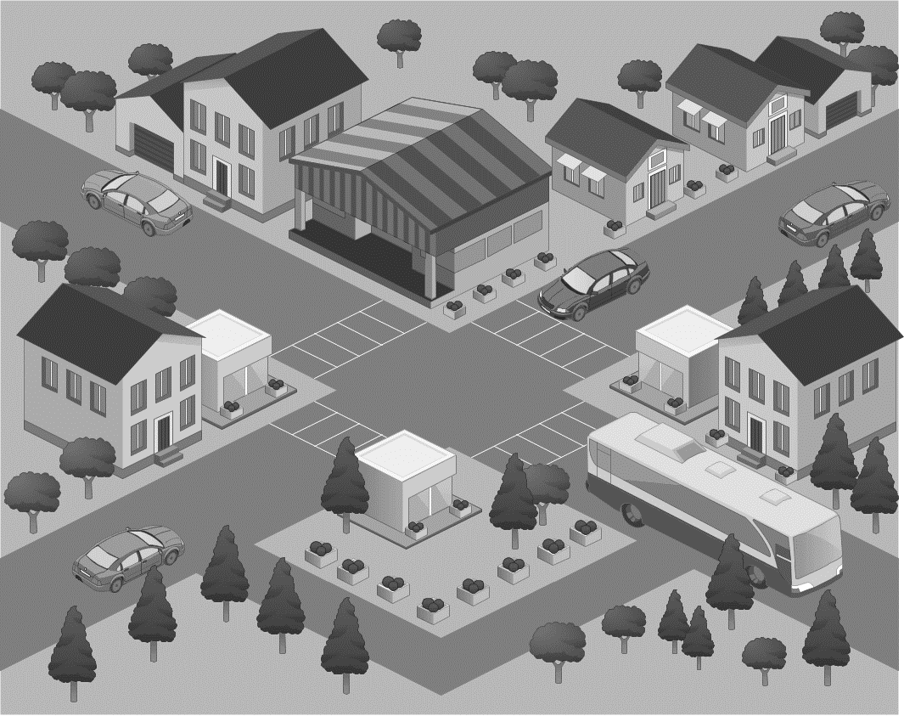

1. Context
2. Thesis
3. Line of Reasoning
4. Evidence
5. Why does your argument deserve to be here?

Anatomy of an Argument

Subject and Direction

Evidence

Evidence

Evidence

Reason

Line of Reasoning

Reason

Evidence

Evidence

Evidence

Reason

Evidence

Evidence

Evidence

Thesis